FX Column: Sales Slide for the Shark Foward
Uwe Wystup, MathFinance AG, Frankfurt am Main

A treasurer with EUR-USD exposure is generally advised to hedge future cash flows against currency movements. The most popular, most used, most applied hedging strategy is to do nothing, wait for better times and check again tomorrow. Let me explain an alternative that has long since become successful because it is easy to sell: the shark forward.
We consider a treasurer who needs to buy USD 10M in 6 months (EUR seller = USD buyer, importer in the EUR zone or exporter in the USD zone).

EUR-USD Market
We consider the currency pair EUR-USD on 5 January 2026 with assumed market data as in Table 1.

Spot | 1.1700 | ATM volatility | 5.75%
USD 6 M Money Market | 3.55% | 25-Delta Risk Reversal | +0.55%
6 M Forward | 1.1800 | 25-Delta Butterfly | 0.25%
Table 1: EUR-USD Market Data as of 5 January 2026

Shark Forward
The shark forward is also called forward plus or forward extra or enhanced forward or forward with profit potential. It is suitable for companies that want to fix a forward price while benefiting from a spot movement they believe in. It gives a certain range of profit potential, while maintaining a worst-case level near the forward rate. It is composed of a synthetic forward contract with an agreed forward price as the worst case and a reverse knock-out option, whose payoff profile looks like a shark fin. Whether the term ‘shark’ is helpful in sales efforts is still investigated. We distinguish two kinds of shark forward contracts.
(shark) forward plus: the treasurer benefits from a favorable spot movement.
(shark) forward extra: the treasurer benefits from a spot movement against his position.

Shark Forward Plus
Importer in the Euro zone: The buyer of 10 M USD, who needs protection against a rising USD (equivalent to falling EUR-USD exchange rate), but expects the USD to weaken, can get a worst case of 1.1700, equal to the current spot and only 1 big figure worse than the outright forward rate, a participation level of 1.1700 and an American style knock out trigger of 1.2400. The market mid price of this strategy is -2,000 EUR, i.e. the treasurer trades the shark forward plus for zero cost and the sell-side keeps EUR 2,000 as a total profit (to be split between sales and trading). The exchange rate the treasurer gets is max(worst case, spot at maturity), as we are looking at the following scenarios.
• If the spot at maturity is below 1.1700, then the client is entitled to buy 10 M USD at the worst case 1.1700.
• If the spot at maturity is above 1.1700 and the trigger has not been touched, then the treasurer can buy 10 M USD at the spot price, higher and better than the worst case.
• If the trigger has been touched, then the treasurer must buy 10 M USD at the worst case.
In both cases the treasurer has a guaranteed worst-case protection at zero cost and can participate in a favorable spot movement. A comparison with an outright forward is illustrated in Figure 1, which resembles a shark fin above the water surface.

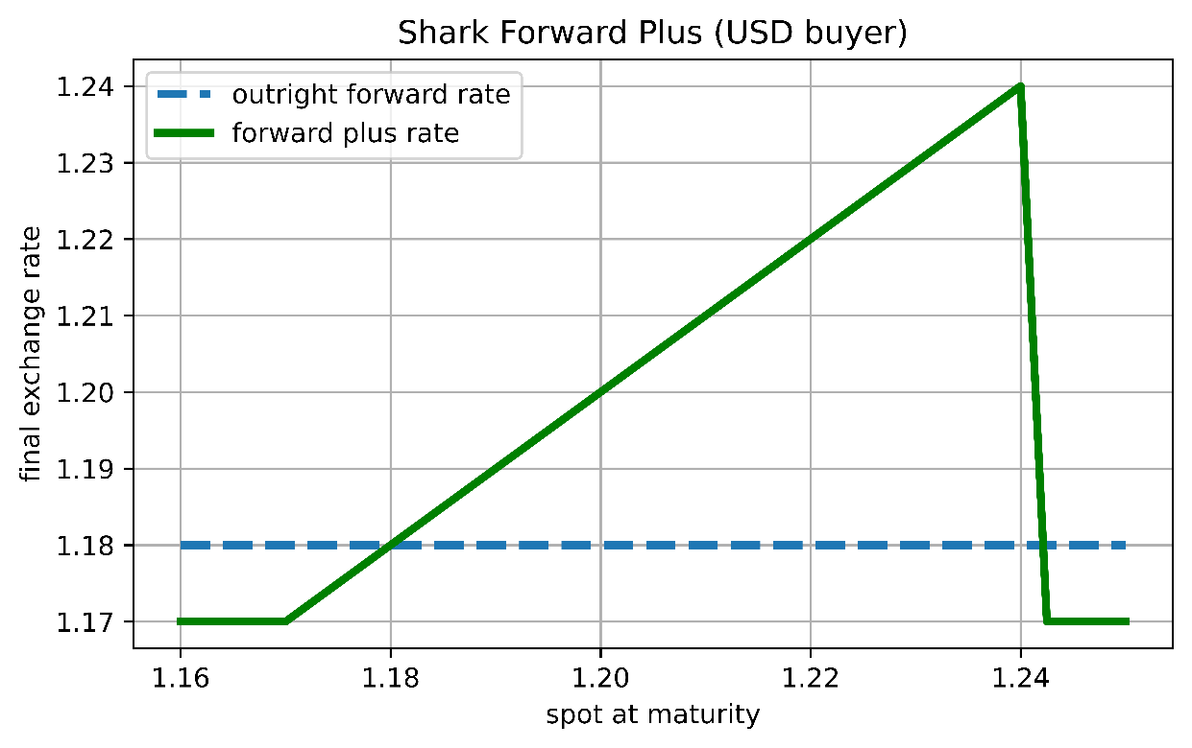
Figure 1: EUR-USD 6-Months Shark Forward Plus: Comparing the Outright Forward Rate with the Effective Exchange Rate on the Spot Space

The Compliant Sales Slide
This is easy to sell: the treasurer locks in a guaranteed worst case of 1.1700 EUR-USD, the current spot rate, for his 10M USD purchase, participates in a weaker USD up to level of 1.2400 EUR-USD, and gets the deal for free. The sales slide in Figure 1 supports the argument that the treasurer gives up very little (the 1 big figure difference between the spot 1.1700 and the forward 1.1800) and gets the entire participation range between 1.1700 and 1.2400 for free.
The sell-side makes a total of EUR 2,000 profit (maybe divided into EUR 800 sales margin and EUR 1,200 traders’ mid-offer spread) and can recycle this structured product multiple times to make it a profitable flow product.
Too good to be true?
First, one may argue that if spot rises to levels above 1.2400, so the barrier is hit and the effective exchange rate bounces back to 1.1700. That might feel like a missed opportunity when it happens, but one can counter-argue that the treasurer still gets the 1.1700 exchange rate, which is today’s spot and which he might have used as a budget rate anyway. And even compared to an outright forward, this is only 1 big figure worse. So compared to the popular do-nothing strategy and compared to the outright forward contract, the shark forward plus can still be viewed advantageous.
Second, the wide range of participation shown in Figure 1 isn’t the full story. It is an example of a fully correct, fully compliant scenario illustration, which is, however, still deceiving. I show in Figure 2 how the participation range shrinks on a wider spot space.

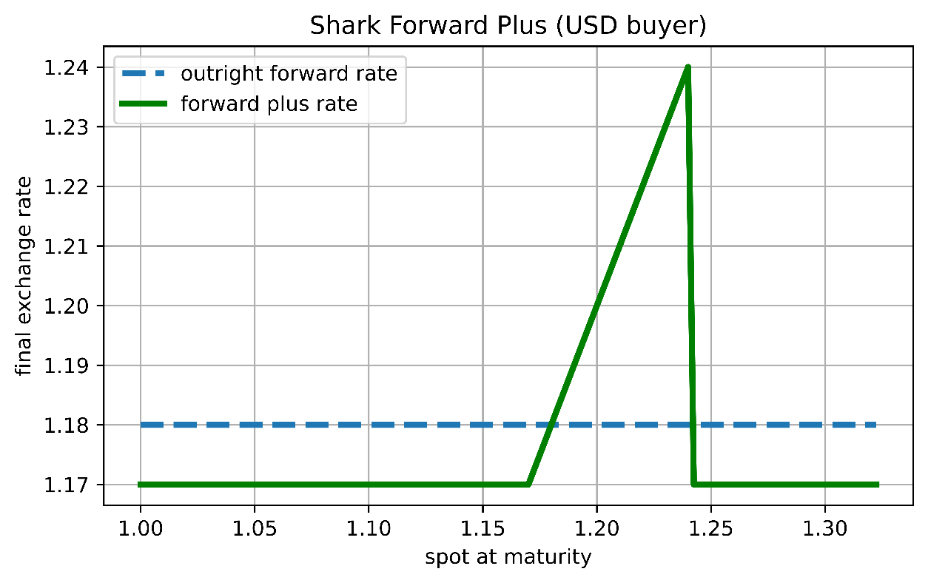
Figure 2: Identical EUR-USD 6-Months Shark Forward Plus: Comparing the Outright Forward Rate with the Effective Exchange Rate on a Wider Spot Space

The sales slide illustrates the scenarios correctly; however, it conceals the many scenarios in which the treasurer faces the worst-case scenario. The upper barrier is hit with 19% probability, and the spot will be below worst case 1.1700 at maturity with 43% probability.
Decomposition
The graphs in in Figure 1 and Figure 2 are not payoffs. The y-axis shows the effective exchange rate the treasurer gets in 6 months depending on the prevailing spot. This type of illustration is more likely what the treasurer is interested in. The structurer on the sell-side needs to compose the shark forward from a range of standard derivatives products. In our example, the treasurer buys a vanilla USD call = EUR put option struck at worst case and sells a vanilla USD put = EUR call option struck at worst case. In combination this is a synthetic USD buyer forward contract. Since the synthetic forward rate is above (i.e. worse) the market outright forward rate, the initial market value of the synthetic forward contract is negative and allows the treasurer to go shopping and buy a EUR call = USD put reverse knock-out option (RKO), see Figure 3. The barrier is chosen to get a total package value slightly negative.
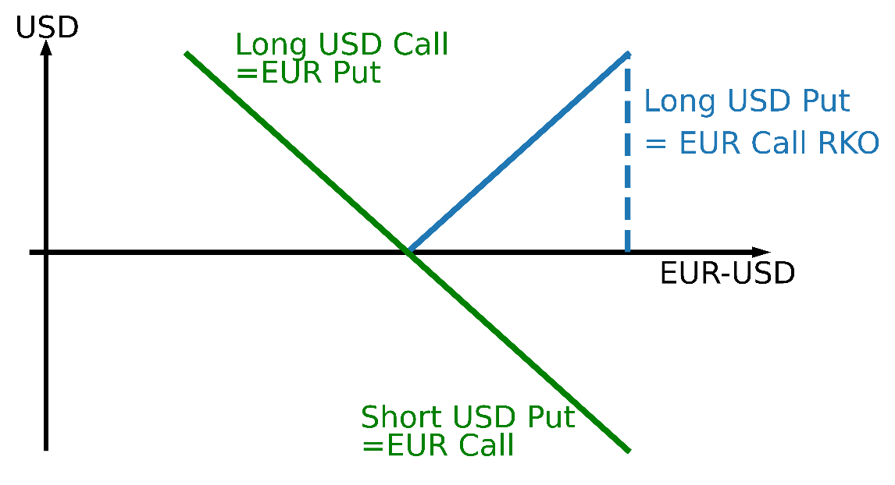
Figure 3: EUR-USD 6-Months Shark Forward Plus: Payoff Diagrams of the Building Blocks

Many trading systems combine the short vanilla EUR call and the long RKO EUR call into a short reverse knock-in (RKI) EUR call, see Figure 4.
The general idea for structured forward contracts with worst case is:
Synthetic Forward with Worst Case + Participation in Market View

In the specific case of a shark forward plus this means:
EUR Put – EUR Call + EUR Call RKO
= EUR put – EUR Call RKI
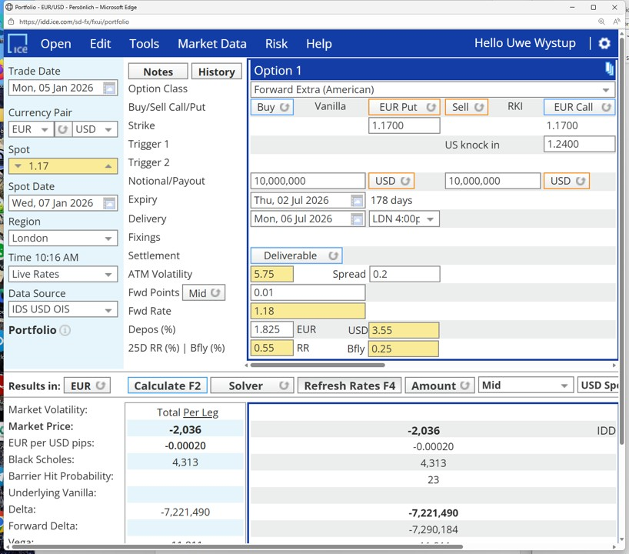
Figure 4: EUR-USD 6-Months Shark Forward Plus (labelled Forward Extra (American) in ICE Data Services
Summary
- The shark forward can turn out to be a very attractive hedging structure, where all parties involved feel they get a deal.
- It is easy to explain and easy to sell in certain market conditions: contango forward for the buyer of the domestic (counter) currency or backwardation forward for the buyer of the foreign currency.
- Fully compliant scenario illustrations may not show event probabilities and can hence further support sales efforts.

References
- Uwe Wystup: FX Options and Structured Products, Second Edition, Wiley 2017.

5 January 2026 – MathFinance AG – Kaiserstraße 50 – 60329 Frankfurt am Main – Germany – www.mathfinance.com

